Graph Exercises

- Write an adjacency matrix, an adjacency list, and a reachability matrix that represent the following graph.
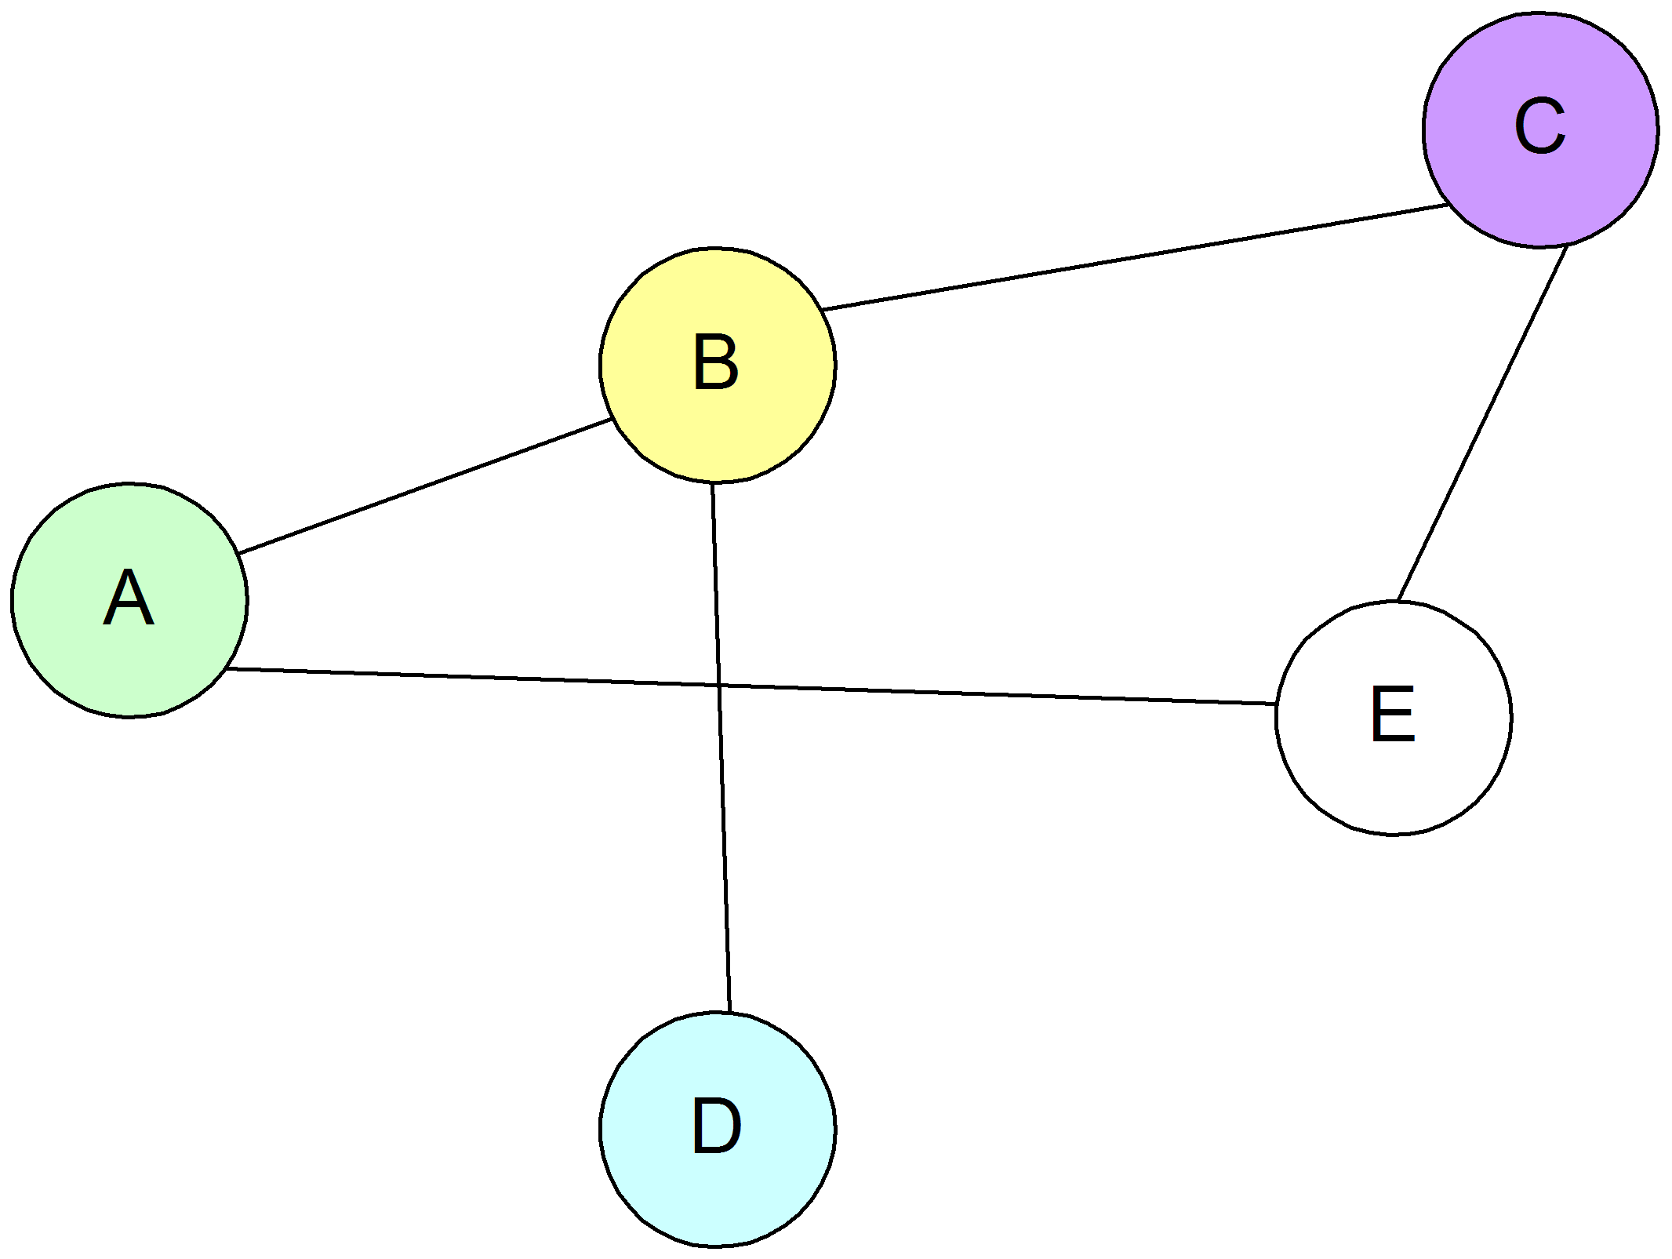

2 a. How many 1's are there in the adjacency matrix that represents the directed graph?
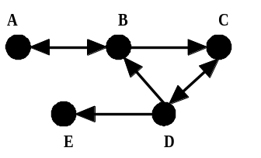

b. Write the adjacency matrix and the reachability matrix.

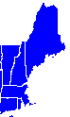
3a. Consider the map of the six New England states, ME, NH, VT, MA, RI, and CT. Draw a graph that shows the neighbors of each state. Write an adjacency matrix and an adjacency list that represent the neighbors of each state.

b. Then write the input file that contains the same information. As an example, a file of the neighbors of VA is given at the right.
KY VA
TN VA
WV VA
VA MD
VA DC
VA NC

3. Represent this physical map as a graph. Then write an adjacency matrix and an adjacency list.

C
B
A
D
E
F
G
H
I
J

